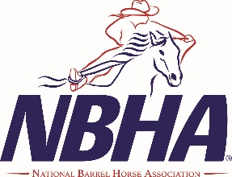
NEBRASKA NBHA STATE FINALS
FRIDAY NIGHT OPEN 5D RACE
June 19TH, 2026 6pm OPEN 5-D $500 ADDED
45.00 entry fee 80% of entry pay back 100% of added money paid back
20.00 processing fee per contestant paid only once for the weekend
If you want to be in the early draw –please enter on the state entry form by the deadline even if you are entering only Friday night THERE IS NO SELLING OF SPOTS IF YOU CANNOT COME!
Contestants can also enter on-site by 5:00 Friday June 19th, 2026 NO LATE FEE FOR THIS RACE! ITS HOT IN JUNE! NO DRESS CODE FOR THIS RACE!!!!!!

NEBRASKA 4D APPROVED!!!! Memberships available for both these organizations at the event!!!!

